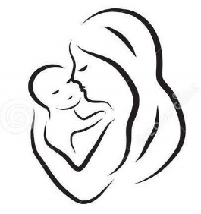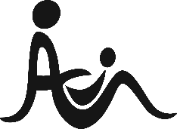**jkl**

**International Association of Infant Massage**

**Me and My Baby: Baby Massage Booking Form**

Please fill in the form below in BLOCK CAPITALS and return to the Coseley Family Hub or email Priscilla at priscilla.meandmybaby@gmail.com

|  |
| --- |
| **Your Name** |
| **Baby’s Name Male / Female** |
| **Baby’s Date of Birth** |
| **Relevant information about your baby e.g. premature, special needs, colic** |
| **How can I contact you? Please tick all that apply:**  **Email**  **Text**  **WhatsApp** |
| **Telephone** |
| **Email** |
| **Date of start of course** |
| **How did you hear about the course?** |
| **I agree to follow the class guidelines. I take full responsibility for myself, my baby and my belongings during the baby massage class. I agree to complete an evaluation form supplied to me at the end of the course.**  **Signature Date** |
| **I agree to anonymous photographs of me and my baby being used to promote the group on advertising and social media posts. No photos of breastfeeding or naked children will be taken. (Giving consent for photos is optional.)**  **Signature Date** |